Final Project Report

Project Title:

Construct and classify the existing characteristics of Titanic passengers, and explore the importance of the classified fields with random forest method

……………….

杨子轩Peko 22

Class number: 2

Course name:
human-computer interaction and visualization technology
Department of Software Engineering
Hebei University
directory
abstract 3
introduction 4
(1)Brief description of the dataset 4
(2)Explanation of relevant features 4
(3) General ideas for solving problems 4
Method and how to implement it 5
result 6
discuss 7
conclusion 8
References 9
appendix 10
(1)Display partial data 10
(2) Show Survival Ratio 10
(3)View the results after processing null values 11
(4)Show the number of times each title appears 11
(5)Display the survival rate of each title 12
(6)New field after construction 12
(7)The importance of features related to personal information 13
(8)The importance of characteristics related to family members 13
(9) The importance of features related to ship tickets 14

abstract
The Titanic impact on an iceberg accident was a sea disaster with a very heavy casualties. The background of the problem to be solved in this article is on April 15, 1912, when the Titanic made its first voyage and sank after colliding with an iceberg, resulting in the death of 1502 out of 2224 people. For such a tragic accident, whether the rescued person survived due to certain features and which features played a greater role in affecting the survival of passengers. In this article, we will first clean and process the existing dataset, and then construct new fields and group them to explore the importance of inter group features.

Keywords: data processing; Random forest algorithm; Machine learning; Feature construction; model training

introduction

(1)Brief description of the dataset
For two given datasets, the first training set train.csv contains passenger information records, which contain 11 features and one label (0,1).
The second dataset is the test set test.csv, which contains 418 samples to be predicted, and the table also contains 11 features. It should be noted that the test set does not have a survival label, and the other fields are consistent with the training set. Afterwards, we need to construct new fields and construct models to evaluate the importance of these fields related to passengers.

(2)Explanation of relevant features
Firstly, the PassengerID represents the ID of the passenger. According to the table, it can be seen that there are a total of 891 passengers in the training set. The second column 'survived' refers to the passenger's survival status, 0 represents death, and 1 represents that the passenger is a survivor. The third column pclass represents the class of the passenger's cabin, the fourth column Name represents the passenger's name, the fifth column sex represents the passenger's gender, the sixth column age represents age, the seventh column sibsp represents the number of the passenger's siblings and spouses together, the eighth column part represents the number of the passenger's parents and children traveling together, the ninth column ticket represents the ticket information, and the tenth column fare is the ticket price, The eleven cabins represent the information of the cabin, and the last embarked column represents the port where passengers disembark.

(3) General ideas for solving problems
Firstly, we need to define the problem and analyze what kind of problem the case is to solve. In this article, we need to predict the importance of passenger feature fields. The second step requires collecting data, and the question has already provided a test set and a training set. The third step is to clean the data. The data currently provided cannot be used directly, which will reduce the accuracy of the prediction. Therefore, we should correct the outlier, fill in the appropriate vacancy values, build new features based on the existing features, and transform the field format. Therefore, the third step is a very important step, which will have a significant impact on the final prediction results, Because the quality of the data in the model can directly affect our evaluation results in the case. The fourth step requires exploration and analysis. We can construct some fields based on the fields already provided in the case. The fifth step is to model the data and use algorithms to predict. In this case, the random forest algorithm is used to explore the importance of features.

Method and how to implement it
First, use pd.read_csv() loads two original datasets and then uses data_raw. info() reviewed the basic information of the dataset and found that if not calculated, some passenger features would be lost. Next, in order to analyze and clean up the entire data, we need to merge these two datasets for unified cleaning, using data_ all=[data_raw, data_val] Merge two datasets into data_all. Before data cleaning, please use.isull().sum() checks which functions are missing, and then calls. describe() (include='all') to view the number of features, average, median, and so on in the original dataset. Then, we start cleaning up the original dataset and using a for loop to fill in the missing values in the missing features. For each missing value of age and distance, we first obtain its missing field and fill it in with a median in this article. Then, inplace=True modifies it in the original dataset. Using drop can delete some fields that have little impact. Used after processing. isull().sum() to view them. If the original null value does not exist, it indicates successful filling.
Afterwards, we used the for loop to construct new features based on the existing fields. I first constructed the "family_size" field for boarding, which consists of the "sibsp" field value plus the "batch" value and the number of people on board. Then, we constructed a "single" field, which is used to count whether each passenger has other family members following the boarding process. Afterwards, the "title" field is constructed. By observing the "name" field, it can be found that each passenger's name has a part that reflects their status. We can extract it and create a new "title" field to store their identity. The specific implementation is to first obtain the "name" field and then convert it to a string type. First, split it with "," and then use split to split it with "." to obtain the first element, which can obtain the identity and status information.
Because some features have a large numerical range, they can be grouped and then counted to determine which group the feature values belong to. The first constructed field is the 'farebin' field, which uses qcut in Pandas to set all values into 4 groups, Afterwards, a similar method was used to construct the age group "age'bin" field. At this time, by examining the number of each feature in the title through data_raw ['title'].value_counts(), it was found that many features have a relatively small number. For the convenience of statistics, all of them less than 10 can be classified as other classes. Furthermore, by using data_raw ['survived']. groupby (data_raw ['title']). mean() and using the matplotlib. plot() library, use the barplot() in Seaborn Draw a bar chart to see the corresponding proportion of each title.
Because the types corresponding to sex and embarked features are character types, for direct training using algorithms and using the LabelEncoder in scikit learn, gender in sex can be divided into two categories. If it is male, replace it with 0; if it is female, replace it with 1; Embarked is the same. Then, continue to use the for loop to construct a new field sex_code, construct a label object, and then call the "fit_transform" method in the label object to place the sex field for construction. The other fields are also similar.

result
Next, we will describe the process of manipulating the processed data to obtain visual results.
There are three ways to demonstrate data training in this article. The characteristics selected for method one are related to the passenger's personal information; The selected features in Method 2 are related to family members related to passengers; Method 3: The selection field is related to the information of the ship and port. After selecting three features, it is also necessary to concatenate them with the surviving field. And it needs to be passed to us in three ways through the "get_dummies()" method in Pandas to select the features for encoding conversion. After conversion, it is displayed in a list format, and several categories of these original fields are converted into several encoding formats.
Partitioning training and testing sets-utilizing models in sklearn_ selection.train_test_split method and perform encoding conversion. Then call the model under sklearn_GridSearchCV in the selection. Then call the RandomForestClassfield (random forest algorithm) under the enable in sklearn. Create the object rf of random forest and call the algorithm and set parameters. We also need to set the required hyperparameter. Here, we use grid search to set many parameter algorithms to verify one by one in the running process. In this paper, there are standard parameters, two hyperparameter "gini" and "entropy". The algorithm will choose which of the two standards is better to run; There are at least a few leaf node parameters that can be set and retained by oneself; There is a minimum number of segmentation times, which is also a self set number of segmentation times. After debugging the algorithm, choose the best solution to return; There are also selection parameters for the number of decision tree constructions. Create a grid search object, pass in the algorithm to the random forest object, and set the parameters at the same time--just pass in the parameters set just now, and set the accuracy as the evaluation standard, and carry out three times of cross validation, and set up multi-threaded operation. At this point, the objects searched for in the grid have been created.
Use the fit method to train feature one by filling in method one with grid objects. After training, gs.best_score can be used to view the best training results. In addition, you can also view the parameter selection under the best training results, using print (gs. best_params_) for implementation. Then create a new object rf2, fill the previous best parameter selection into the RandomForestClassfield, and then use the second random forest object to fit the training data set. During prediction, use concat in Pandas to splice the two tables and sort them according to the importance of features. The other two schemes can also be implemented by using similar methods. These three schemes are visualized by heatmap() function in seaborn library in the form of thermogram, barh() method in Matplotlib library in the form of gradient color bar, and barplot() function in Seaborn library in the form of bar chart to visualize the importance ranking of random forest features.

discuss
For the first set of features, regarding the passenger's personal characteristics, this set of features utilizes gs.best_score_ ,the best score for viewing the model on the training set is approximately 0.793. In the visualization results of feature importance, it can be seen that the proportion of importance of "title-Mrs" is the highest, and at that time, Ms also represented married women. Their high proportion of importance may be due to the husband prioritizing the safety of his wife. The importance of 'sex_code' and 'sex_male' ranks second and third, indicating that gender is also a very important factor. The high importance of males may be due to the moral code of 'women first' in the social environment at that time, and the number of male passengers is also higher than that of females. Therefore, the feature of 'sex_male' is more important for the model. Although age is also a relatively important factor, the presentation of the results is not very important. It may be because age is a continuous variable, and processing such fields in the model is more complex in calculation. Therefore, the influence of fields such as age is relatively less significant than that of gender and title.
For the second set of features, it is a set of features related to whether there are people traveling with passengers, which utilizes gs.best_ score_ The best score for viewing the model on the training set is approximately 0.660. 'single '- whether to be alone or not,' parch '- the number of parents and children,' family_size '- the number of family members, and' single 'has the highest importance, possibly because in times of crisis, a person generally only needs to ensure their own safety and does not need to consider accompanying family members; Secondly, there is the field 'parch', which is more important because the rescue policy prioritizes rescue for the elderly and children, and the importance of 'family_size' is relatively low. This may be because the number of family members may not necessarily have a significant impact on survival. When there are many family members, they may help each other to improve survival rates, but it may also be due to too many members leading to slower escape, depending on the situation.
The third set of features is related to the ticket, which utilizes gs. best_ score_ The best score for viewing the model on the training set is approximately 0.703. The main focus is on "embarked_code" - the port number for boarding the ship, and "fare bin code" - the fare range code. It can be seen from the results that port codes have a significant impact on survival rates, as port codes may represent factors such as their social and economic background, which may also affect their ability to escape. For ticket price encoding, its importance is relatively low, possibly because the encoding of the ticket price is obtained from discrete continuous variables, which may cause some degree of information loss and lead to a decrease in importance.

conclusion
It can be seen that in the experiment, the three sets of data related to passenger personal information, passenger family members, and ticket information were divided using gs.best_score_ The scores are 0.793, 0.660, and 0.703, respectively. For these three sets of information, the features related to personal information have the strongest correlation with whether passengers can survive, followed by the features related to ship ticket information, and the features related to family members have weaker correlation with survival.
Among them, title and gender occupy a relatively important position in the first group of characteristics related to passengers; Among the characteristics related to family members, whether to board a ship alone became the most important factor in the second group; In the third group, the port number of boarding is the most important part in the ticket information.Therefore, when selecting features, we can determine the most representative features and evaluate and compare the model using methods such as cross validation. This method can also improve the accuracy of the model in predicting other results.

References
[1] The basic core idea of random forest algorithm，https://blog.csdn.net/weixin_37773108/article/details/105969844 2020-05-07 12:16:17
[2] Liu Yong, Xing Yanyun Research and Application of Text Classification Based on Improved random forest Algorithm[J].Computer System Applications,2019,28(5):220-225. DOI:10.15888/j.cnki.csa.006927.
[3] Analysis of Titanic Survival Prediction https://zhuanlan.zhihu.com/p/371416196 2021-05-11 15:18

appendix

(1)Display partial data
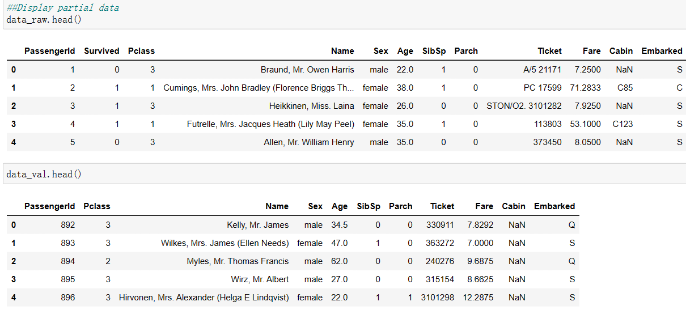

Show Survival Ratio
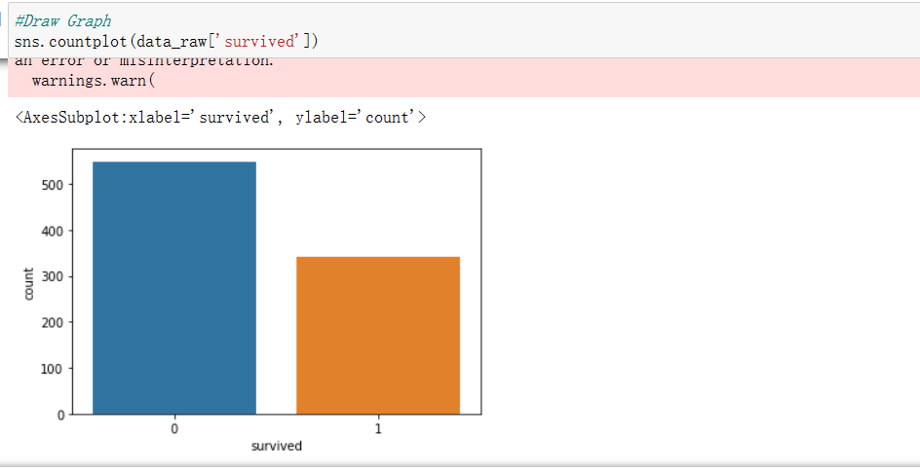

(3)View the results after processing null values
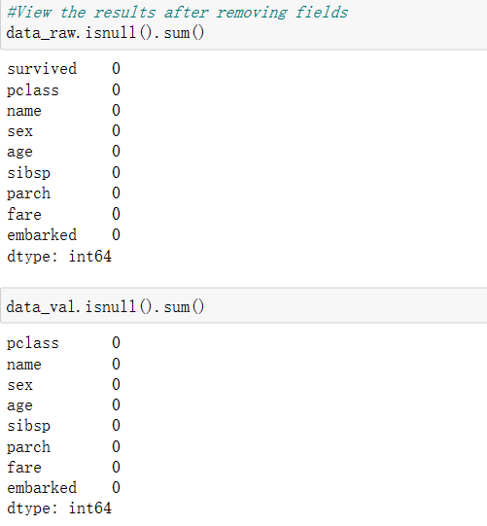

(4)Show the number of times each title appears
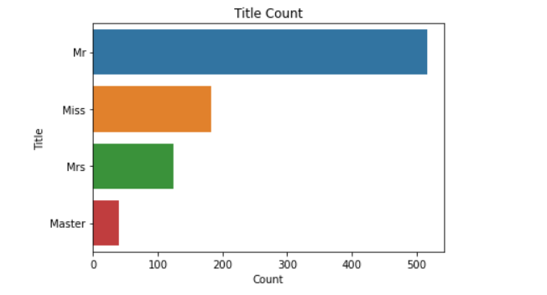

(5)Display the survival rate of each title
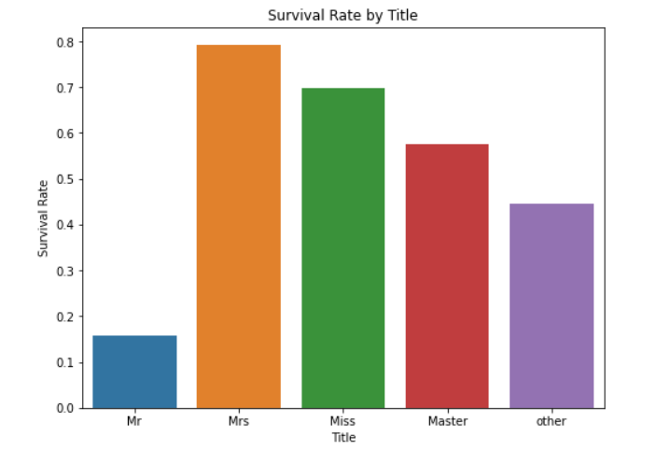

(6)New field after construction
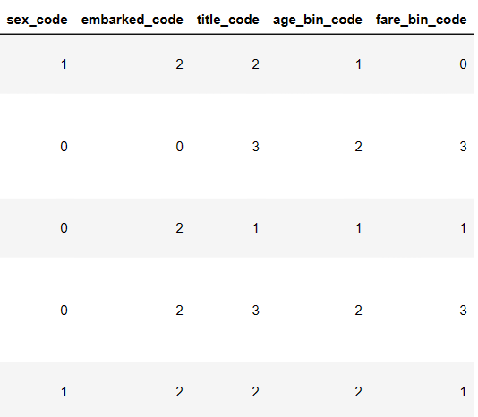

(7)The importance of features related to personal information
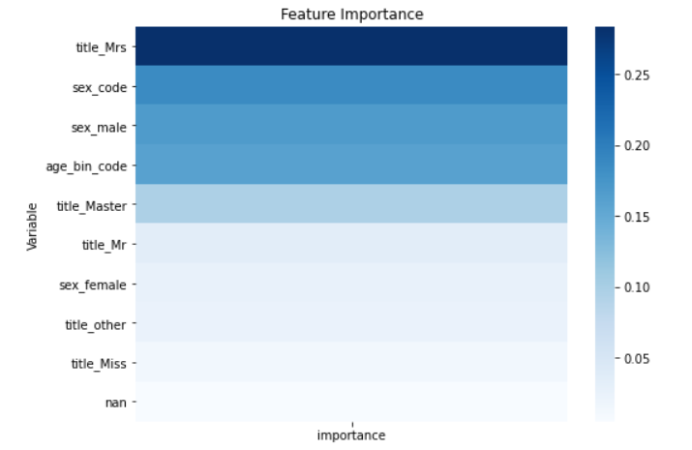

(8)The importance of characteristics related to family members
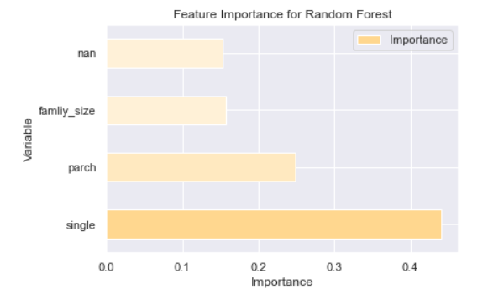

The importance of features related to ship tickets
